Lorcheen Olbinar

IT64 (IT36A)

# Introduction

The simple ToDo list app that was generated was made using the React and Ionic frameworks. Users can add, edit, and remove ToDo items in addition to having sign-up, login, and logout features for user authentication. Firebase Authentication and Firestore are used to handle user administration and data storage.

# Features

**User Authentication:**

* **Sign Up:** Users can register for an account by providing their name, email, and password.
* **Login:** Users can log in to their accounts using their email and password.
* **Logout:** Users can log out of their accounts.

# Description of Your Works (Systems) Login System

* Provides a login interface where users can input their email and password.
* Authenticates users using Firebase Authentication.
* Checks if the user exists in Firestore, and redirects to the home page upon successful login.

# Sign-Up System

* Provides a sign-up interface where users can register by providing their name, email, and password.
* Validates user inputs and displays appropriate error messages.
* Stores user data in Firestore upon successful sign-up.

# Conceptual Framework

The application has a client-server architecture, where the client-side is built with the React and Ionic frameworks, and server-side tasks like authentication and data storage are handled by Firebase services (Authentication and Firestore). The client and server communicate to perform CRUD operations on ToDo items and authentication tasks.

**The System (Screenshot of your Output)**

# Login Display Screen Sign-Up Display Screen

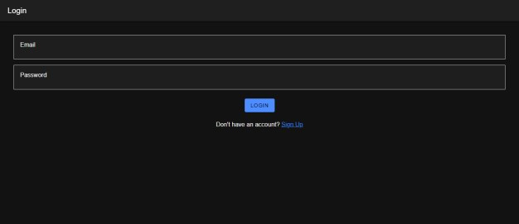 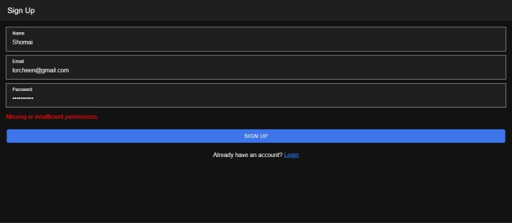

**Firebase Display Screen**

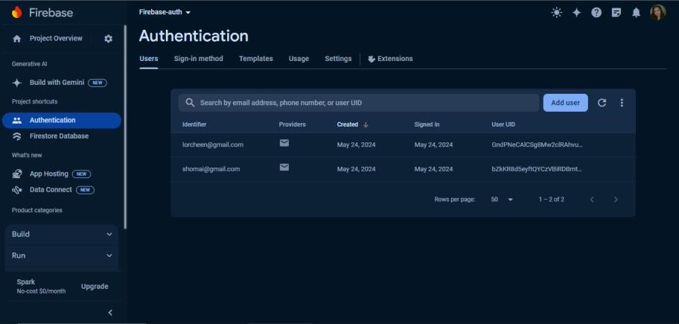

**Reference:**

Olbinar, L. (2024, May). ToDo List Application. Retrieved from https://github.com/Lorcheen0814/OLBINAR-FINALPT.git